**ASSIGNMENT 3**

| Student Name | SIVASHREE K |
| --- | --- |
| Student Roll Number | 6113191031097 |
| Maximum Marks |  |

**1.Create bucket in cloud Account:**

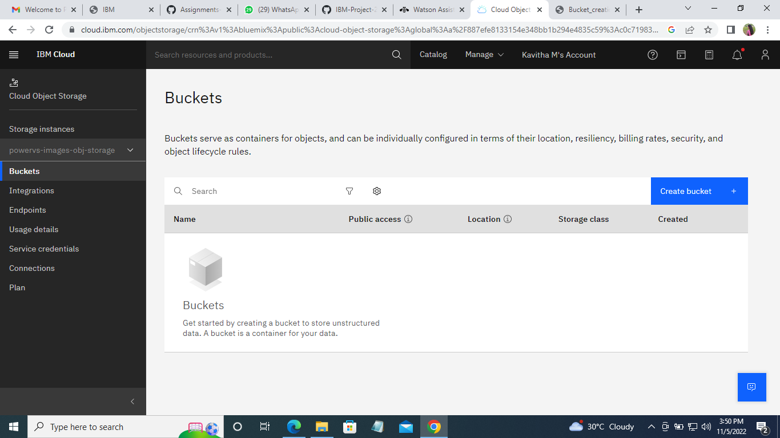

**2.** **Upload an 5 images to ibm object storage and make it public. write html code to displaying all the 5 images.**

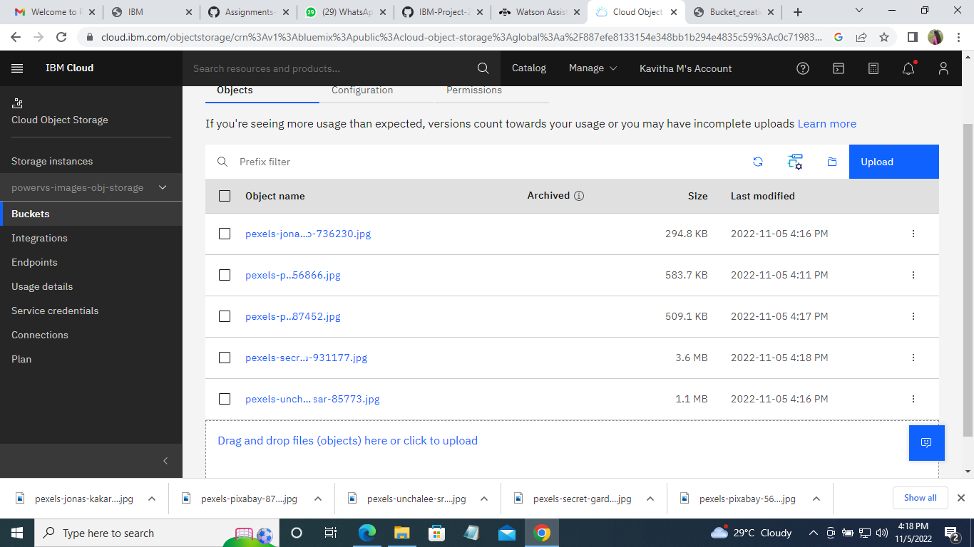

**Code:**

<!DOCTYPE html>

<html>

<head>

<link rel="stylesheet" href="https://plasma-images.s3.jptok.cloud-object-storage.appdomain.cloud/style.css">

</head>

<body>

<img src="https://powervvs-images.s3.jp-tok.cloud-objectstorage.appdomain.cloud/pexels-pixabay-56866.jpg" alt="HTML5 Icon" >

<br>

<img src="https://powervvs-images.s3.jp-tok.cloud-objectstorage.appdomain.cloud/pexels-unchalee-srirugsar-85773.jpg" alt="HTML5 Icon">

<br>

<img src="https://powervvs-images.s3.jp-tok.cloud-objectstorage.appdomain.cloud/pexels-pixabay-87452.jpg" alt="HTML5 Icon" >

<br>

<img src="https://powervvs-images.s3.jp-tok.cloud-objectstorage.appdomain.cloud/pexels-secret-garden-931177.jpg" alt="HTML5 Icon">

<br>

<img src="https://powervvs-images.s3.jp-tok.cloud-objectstorage.appdomain.cloud/pexels-jonas-kakaroto-736230.jpg" alt="HTML5 Icon">

<br>

</body>

</html>

**3. Upload a css page to the object storage and use the same page in your HTML code**

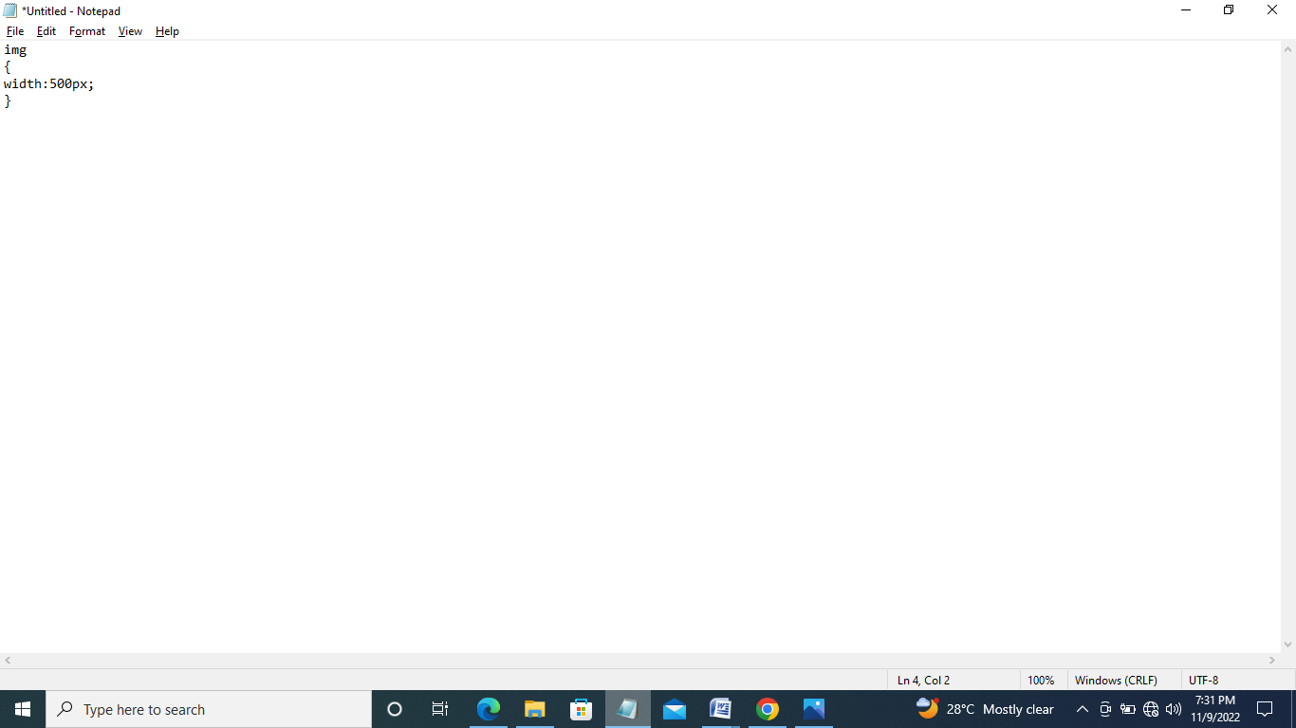

**Output:**

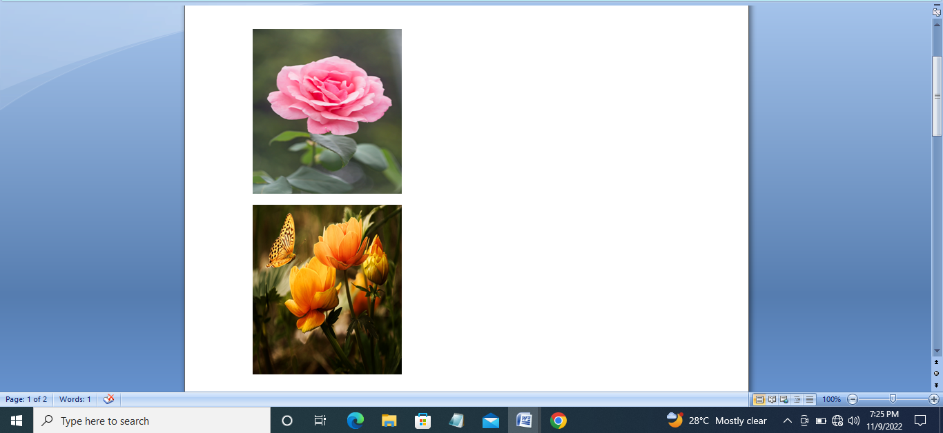

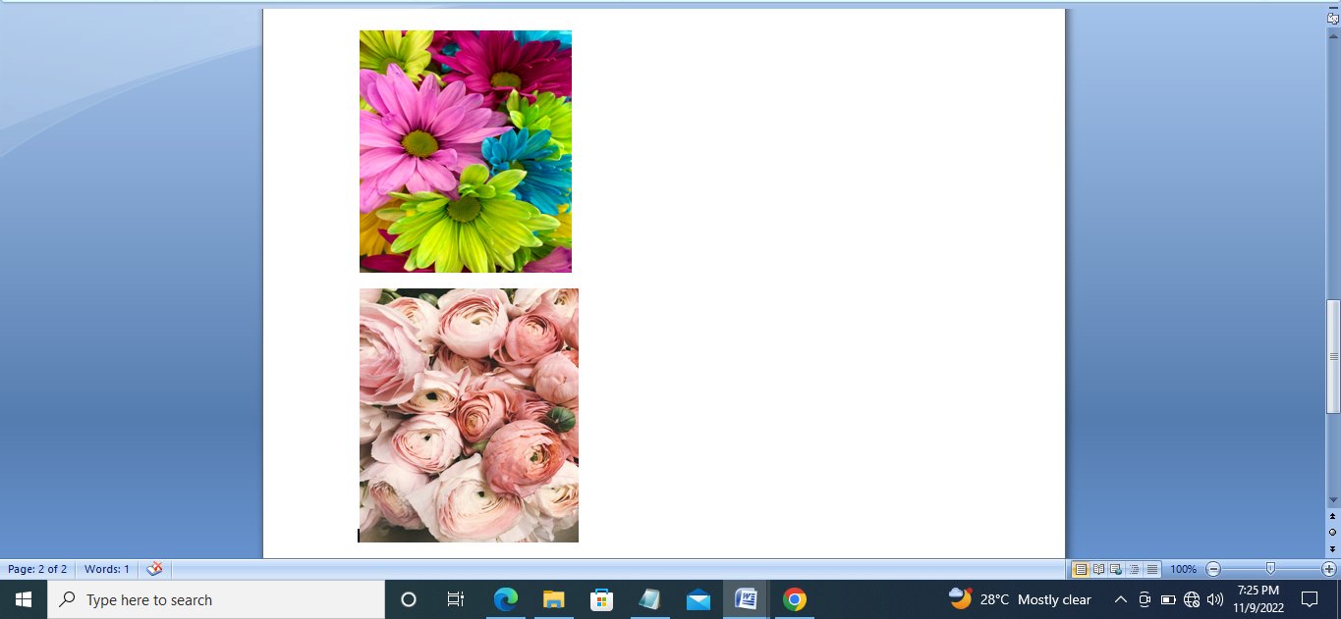

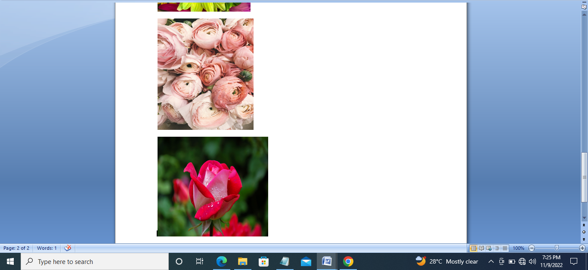

**4.Chat Bot:**

[**https://web-chat.global.assistant.watson.appdomain.cloud/preview.html?backgroundImageURL=https%3A%2F%2Fau-syd.assistant.watson.cloud.ibm.com%2Fpublic%2Fimages%2Fupx-178df40d-5586-4825-9f4a-c12e37497868%3A%3A9df9327e-05d1-4113-9477-d3fdcc7e4548&integrationID=776d2754-4966-4a1e-ab7b-4bfaa9e8bdd0&region=au-syd&serviceInstanceID=178df40d-5586-4825-9f4a-c12e37497868**](https://web-chat.global.assistant.watson.appdomain.cloud/preview.html?backgroundImageURL=https%3A%2F%2Fau-syd.assistant.watson.cloud.ibm.com%2Fpublic%2Fimages%2Fupx-178df40d-5586-4825-9f4a-c12e37497868%3A%3A9df9327e-05d1-4113-9477-d3fdcc7e4548&integrationID=776d2754-4966-4a1e-ab7b-4bfaa9e8bdd0&region=au-syd&serviceInstanceID=178df40d-5586-4825-9f4a-c12e37497868)

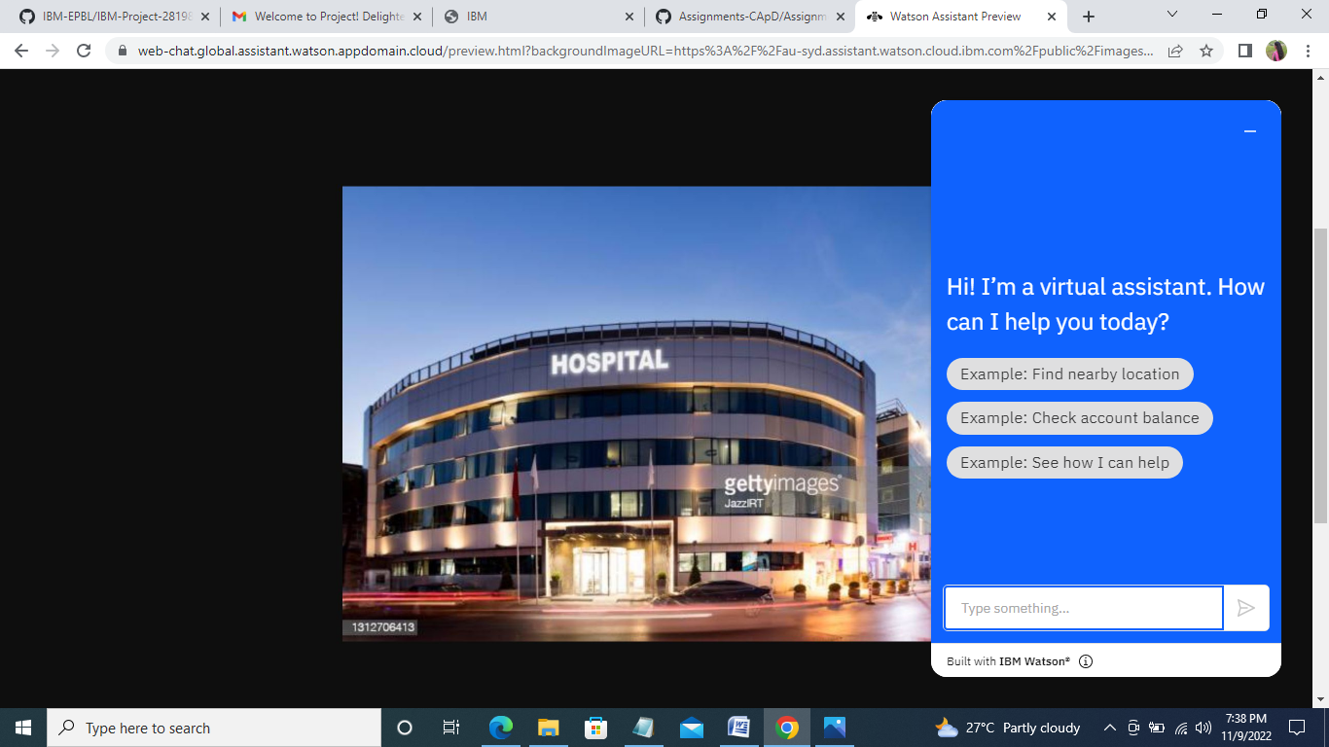

**5.**